4 Chords C, F, G7, D7

**We’d like to Teach the World to Sing**



**Intro: C**///|**D7**///|**G7**///|**C**/// 4 beats to the bar

(starts on note **G** - open G string/3rd fret E string)

**We’d** like to build the world a home

And [D7] furnish it with love

Grow [G7] apple trees and honey bees

And [F] snow white turtle [C] doves.

**We’d** like to teach the world to sing

In [D7] perfect harmony

**We’d** [G7] like to hold it **our** arms

And [F] keep it compa-[C]-ny.

**We’d** like to see the world for once

All [D7] standing hand in hand

And [G7] hear them echo through the hills

For [F] peace throughout the [C] land.

That’s the song **we** hear,

Let the world sing [D7] today

[G7] A song of peace that echoes on

And [F] never goes a-[C]-way away.

**We’d** like to teach the world to sing

In [D7] perfect harmony

**We’d** [G7] like to hold it **our** arms

And [F] keep it compa-[C]-ny.

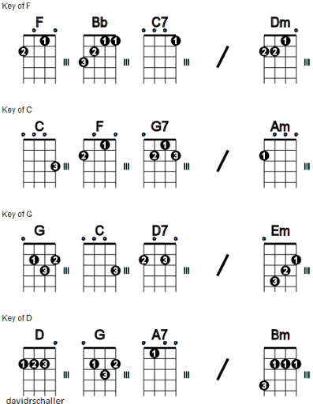That’s the song **we** hear,

Let the world sing [D7] today

[G7] A song of peace that echoes on

And [F] never goes a-[C]-way away.

[G7] A song of peace that echoes on

And [F] never goes a-[C]-way. ///|/

1 2 3 4 1 2 3 4