Key D major 6 CHORDS: A7, D, D7, F#m, G,

*The Seekers 1967*

*YouTube same key*

ttps://youtu.be/z4ZipKdI1sY

**The Carnival is Over**

**Intro: D** 2 3 4 │**A7** 2 3 4│**D** 2 3 4 │**A7** 2 4 beats to bar

Say good-[D]-bye my own true [A7] lover

As we sing a lover’s [D] song.

[D7] How it [G] breaks [A7] my heart to [D] leave you,

Now the [G] carnival is [A7] gone. 2 3 4 **|** 1 2

High a-[D]-bove, the dawn is [A7] waking

And my tears are falling [D] rain,

[D7] For the [G] carni-[A7]-val is [D] over

We may [G] never [A7] meet a-[D]-gain.

[D7] Like a [G] drum, my [A7] heart was [D] beating

And your [G] kiss [A7] was sweet as [F#m] wine,

[D7] But the [G] joys of [A7] love are [F#m] fleeting

For Pier-[G]-rot and Colum-[C]-bine.

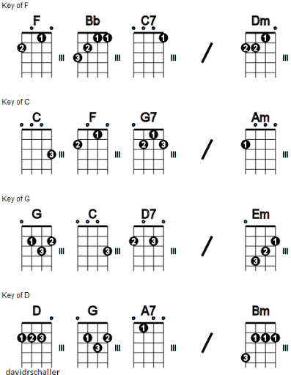

[A7] Now the [D] harbour light is [A7] calling

This will be our last good-[D]-bye,

Though the [G] carni-[A7]-val is [D] over

I will [G] love [A7] you till I [D] die.

[D7] Like a [G] drum, my [A7] heart was [D] beating

And your [G] kiss [A7] was sweet as [F#m] wine,

[D7] But the [G] joys of [A7] love are [F#m] fleeting

For Pier-[G]-rot and Colum-[C]-bine.

[A7] Now the [D] harbour light is [A7] calling

This will be our last good-[D]-bye,



Though the [G] carni-[A7]-val is [D] over

I will [G] love [A7] you till I [D] die.

[D7] Though the [G] carni-[A7]-val is [D] over

I will [G] love [A7] you till I [D] die 2 3 4 **|** 1