9 Chords: G, Gm7, G6, Am, D7, G7, C, Cm6, Bbdim

**La Vie En Rose**

*Cynthia Lin - YouTube*

[La Vie En Rose // Ukulele Tutorial](https://www.youtube.com/watch?v=wIUAG_xF6lE&t=81s)

**Intro: G** *[1 bar]* 4 beats to bar

D DU D DU

1 2 & 3 4 & *[Swing strum throughout]*

[G] Hold me close and hold me [Gm7] fast,  
The magic spell you [G6] cast  
This is La vie en [Am] ro-[D7]-se.

[Am] When you kiss me, heaven [D7] sighs

And though I close my [Am] eyes,  
[I [D7] see La vie en [G] ro-[D7]-se.](https://genius.com/2287669/Louis-armstrong-la-vie-en-rose/This-is-la-vie-en-rose)

[G] When you press me to your [Gm7] heart  
I'm in a world a-[G6]-part,  
A [G7] world where roses [C] bloom

[Cm6] And when you speak angels [G] sing from above,  
[Bbdim] Everyday words seem to [Am] turn into [D7] love songs,

[G] Give your heart and soul to [Gm7] me

And life will always [Am] be

La [D7] vie en [G] rose. D DU D DU D

1 2 & 3 4 & 1

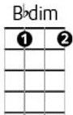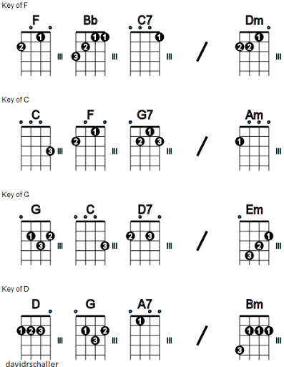

GM7

0 2 2 2

